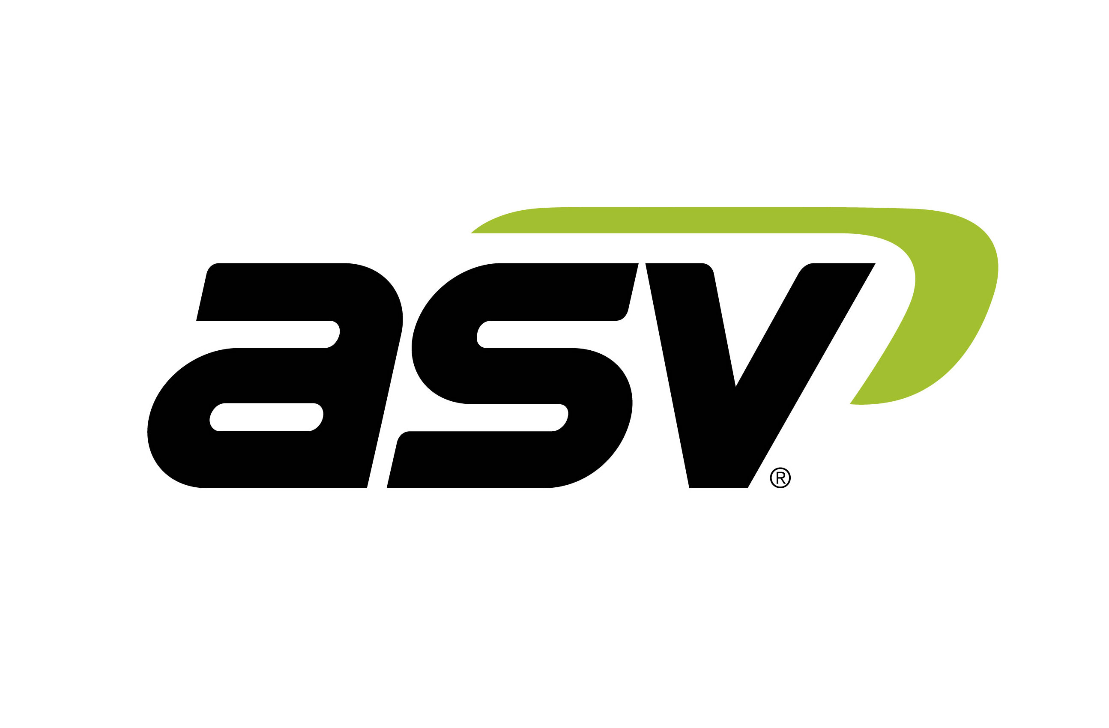 | Contacts:  Regan Meyer  218-327-5385  regan.meyer@asvi.com  www.asvi.com  Aaron Boerner  701-373-0062  aaron@ironcladmktg.com  www.ironcladmktg.com
FOR IMMEDIATE RELEASE

ASV Features VT-70 Vertical Lift Compact Track Loader for Superior Performance in Lift-and-Carry Applications

ANAHEIM, Calif. (Feb. 17, 2019) — ASV Holdings Inc., an industry-leading manufacturer of all-purpose and all-season compact track loaders and skid steers, offers the company’s first mid-frame, vertical lift compact track loader, the Posi-Track VT-70. The machine features a vertical lift loader linkage for applications requiring extended reach and level loads, such as loading pallets and handling hay bales. The VT-70 features best-in-class rated operating capacity, cooling systems and hydraulic efficiency. The compact track loader excels at lift, carry and load tasks as well as heavy digging in industries such as rental, agriculture, construction and excavation.

ASV displayed the VT-70 at The ARA Show 2019 in Anaheim, California.

“Our mission is to offer our customers the best, highest-performing machines for all of their jobs,” said Justin Rupar, ASV Holdings Inc. vice president of sales and marketing. “That’s why we’re offering the vertical-lift VT-70 in addition to our existing, full range of radial lift machines. The compact track loader delivers all of the productivity, efficiency and power our customers have come to expect from ASV. It’s how we continue to reach our goal of maximum performance with no compromises.”

ASV builds the VT-70 from the ground up. The innovative undercarriage features ASV’s patented Posi-Track rubber track suspension. The single-level suspension is made up of two independent torsion axles per undercarriage, allowing for a smooth ride over every type of terrain and speeds as fast as 11 mph. The VT-70 also includes ride control that dampens the load in the bucket to limit material loss and improve operator comfort. In addition, the multiple wheel contact points, central drive lug and outside guide lug virtually eliminate track derailment and facilitate maximum performance on steep slopes. The VT-70 comes standard with 15-inch-wide tracks, resulting in a ground pressure of only 4.6 psi. Those features, combined with the VT-70’s 13 inches of ground clearance, allow the unit to work in more places, in a wider range of conditions and more comfortably than competitive machines.

ASV transformed its undercarriage from its previous closed design — similar to what is used on competitive steel-embedded undercarriages — to an open-rail and drive-sprocket design. The result is longer sprocket and bogie life along with easier and faster undercarriage cleaning. ASV manufactures all rollers with mechanical face seals that don’t require maintenance for the life of the machine. Embedded co-polymer cords give the tracks extra strength. The tracks are produced using a single-cure process, eliminating cure-point weaknesses that can lead to premature breakage. The process allows for a 1,500- to 2,000-hour track life — 30 percent more than steel-embedded track units. ASV backs the track life with an industry-leading two-year, 1,500-hour track warranty.

The VT-70 features a Kubota 2.4-liter turbocharged diesel engine. The 65-horsepower engine produces 146 foot-pounds of torque. Drive motors transfer the torque to the patented internal-drive sprockets. Internal rollers reduce friction loss in the undercarriage, resulting maximum power being transferred to the track regardless of drive speed. The VT-70 achieves Tier 4 Final compliance using a diesel oxidation catalyst that features less wiring and requires no regeneration, sensors, diesel exhaust fluid or additional maintenance.

The VT-70 boasts industry-leading serviceability, featuring a swing-out door and cooling system along with a three-panel hood arrangement that allows total access to the engine, filters and other daily checkpoints.

ASV built the VT-70’s auxiliary hydraulic system to operate efficiently with an optional 28.4 gpm high flow and 3,300 psi. The machine includes large line sizes, hydraulic coolers and direct-drive pumps — rather than belt-driven pumps — transferring more flow and pressure directly to the attachment and preventing power loss. This design optimizes performance so operators can run attachments more efficiently than higher-horsepower competitive units. As a result of belt-driven pumps and restrictions in their hydraulic systems, many competitive machines lose as much as 30 percent of their horsepower.

The VT-70 features a rated operating capacity of 2,328 pounds and a tipping load of 6,650 pounds. It is 66 inches wide and has a 10.5-foot lift height. Standard joystick controls make operation easy and intuitive, while a self-leveling system allows attachments to stay at a set position while lifting. Operators can use the unit with all standard attachments, such as pallet forks, buckets, snow blades and brush cutters. An optional turf track allows for operation on highly manicured surfaces, such as golf course greens, with minimal risk of damage. A 16.5-inch aggressive track is also available for a lower ground pressure of 4.2 psi along with increased traction and flotation.

For more information on the VT-70 and available options, visit ASV Holdings Inc.’s website: www.asvi.com. Interested in seeing or test driving the equipment? Visit a dealer.

About ASV
ASV Holdings Inc., a publicly traded company on NASDAQ, designs and manufactures a full line of compact track and skid-steer loaders primarily for the construction, landscaping and forestry markets. Located in Grand Rapids, Minnesota, ASV started in 1983 and was one of the pioneers in the compact track loader industry. ASV builds its compact track loaders using unique and patented Posi-Track undercarriage technology that provides exceptional traction on soft, wet, slippery, rough or hilly terrain. Posi-Track is a registered trademark of ASV Holdings, Inc. For more information: ASV Holdings Inc., 840 Lily Lane, Grand Rapids, MN 55744; call 1-800-205-9913; fax 218-327-9122; sales@asvi.com; www.asvi.com; Facebook and YouTube.

###

IMAGE: ASV_VT-70_Static.jpg
CUTLINE: ASV displayed the VT-70 at The ARA Show 2019 in Anaheim, California. Photo Courtesy of ASV

IMAGE: ASV_VT-70_Bucket.jpg

CUTLINE: The mid-frame VT-70 compact track loader from ASV Holdings Inc. features special vertical lift loader linkage for applications requiring level loads, extended lift or increased reach. Photo Courtesy of ASV

IMAGE: ASV_VT-70_Construction.jpg
CUTLINE: The compact track loader excels at lift, carry and load tasks as well as heavy digging in industries such as rental, agriculture, construction and excavation. Photo Courtesy of ASV

Suggested Tags: ASV Holdings Inc., Compact Track Loaders, VT-70, Vertical Lift, Rubber Track Undercarriage, Construction Equipment

Suggested Social Post: @ASVHoldings offers the Posi-Track VT-70 compact track loader. The mid-frame machine features special vertical lift loader linkage for applications requiring level loads or extended lift or reach. {link and photo}

Facebook Social Handle: @ASVHoldings

YouTube Handle: @ASV Holdings Inc.

