Contacts
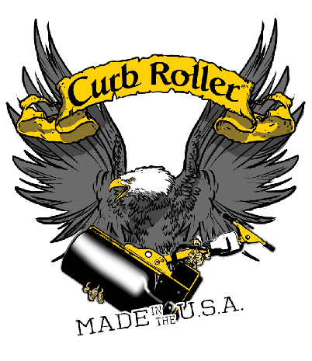
Whitney Haynie Curb Roller Manufacturing
785-467-3132
whaynie@curbroller.com

Caitlin Hanson
IRONCLAD Marketing
701-373-0062
caitlin@ironcladmktg.com

FOR IMMEDIATE RELEASE

Curb Roller Manufacturing Debuts Lynx Modular Roller Screed
LAS VEGAS, (January 18, 2021) – Curb Roller Manufacturing, the world leader in shaped concrete roller screeds, developed its first modular screed system, the patent pending Lynx Screed. This versatile alternative to completing flatwork provides a series of linkable screed pipes to accommodate concrete pours in varying widths from 3 to 22 feet. Unlike traditional roller screeds, the Lynx modular system removes the need for purchasing dedicated pipe lengths to offer easy adaptability for a multitude of pours. Its aluminum design decreases strenuous set up, shipping costs and transportation requirements for jobs that call for longer pipes.
Curb Roller Manufacturing will highlight the Lynx Screed, along with other products and technologies, at booth D420 in the Diamond Lot at World of Concrete, January 18-20, in Las Vegas.
“Screed adaptability and efficiency have been two of the biggest obstacles for concrete contractors’ productivity,” said Seth Ulmer, Curb Roller Manufacturing sales manager. “With our Lynx Screed, contractors can work on pours ranging from a 22-foot-wide street to a 5-foot-wide sidewalk in the same day with just a few sections of pipe that can fit in a standard pickup.”
The Lynx modular screed system, compatible with the manufacturer’s Eel and Batt screeds, is available in two packages. Package one consists of three 7-foot pipes and package two contains a 5-, 7- and 9-foot pipe. The system can also be customized to include any 3-, 5-, 7- and 9-foot length combination up to 22 feet.
In addition to more versatility over standard roller screeds, the Lynx Screed offers greater ease of use and reliability compared to other modular systems on the market through its quick and secure field assembly design. The Lynx pipes are easily aligned and connected with three separate bolts and a centering ring.
The operator simply places the centering ring between two pipes, securely seating them together. From there, the cut outs at the pipes’ ends allow the operator to easily insert three bolts, securing the pipes together by tightening the nuts. With this setup, users don’t have to retighten their pipes mid-job or worry about unthreading when changing screeding directions.
The Lynx Screed system eases maintenance and setup by using different size nuts and bolts, 9/16 and 11/16, enabling contractors to use a single, common wrench set for assembly and disassembly. The Lynx setup is completed by bolting drive and static heads to the assembled pipe’s ends and then connecting to Curb Roller Manufacturing’s electric Eel Screed or battery-powered Batt Screed.
“Until recently, those looking for flexibility were stuck with cumbersome A-frame screeds or expandable roller screeds that require constant retightening or special tools,” said Ulmer. “With our stable connection points, customers can quickly assemble and complete the job — no hassle, no holdups.”
For more information, visit www.curbroller.com.

About Curb Roller Manufacturing
Curb Roller Manufacturing has been the world leader in shaped concrete roller screeds for more than 10 years. With high-quality products for everyday concrete work, Curb Roller’s ergonomic machines not only make it easy to shape standard curb, gutter, and sidewalks, but also flume, v-gutter, swale, and other unique shapes. For more information: Curb Roller Manufacturing, 112 South Main, Fairview, Kan., 66425; 785-467-3132; info@curbroller.com; www.curbroller.com; or on Facebook.
###
Photo: CurbRollerManufacturing_LynxScreed_1
Cutline: With the Lynx Screed System, crews can adapt to various sized concrete pours faster than non-modular systems, which require custom ordering dedicated pipe lengths. Additionally, the Lynx Screed eases logistics challenges for jobs requiring pipe lengths up to 22 feet.

Photo: CurbRollerManufacturing_LynxScreed_2
Cutline: Curb Roller Manufacturing’s Lynx Screed System comes in two packages that consist of three 7-foot length pipes or 5-, 7- and 9-foot length pipes. The screed can also be customized to include any length combination up to 22 feet.

Suggested Tags: Curb Roller Manufacturing, Screed, Lynx Screed, Concrete, Roller Screed, World of Concrete 2022

Publication Social Post: Curb Roller Manufacturing showcases its first modular screed system, the Lynx, at World of Concrete 2022. The screed allows operators to link together multiple screed pipe sections, up to 22 feet, rather than carry dedicated pipe lengths as seen with traditional roller screeds.

